UNIVERSITY OF CANTERBURY

ENME418 Engineering Management

Feasibility Study

Dairy shed manure collection for methane and methanol production through on-farm bio-processing

A Methanex New Zealand Limited Company Venture

Chris Matthews
68522879

George Legget
14713978

06/10/2016

1. Executive Summary
Methanex is proposing to enter the market to produce methanol from biogas, more specifically bio gas retrieved from New Zealand dairy farms. The project proposed will make use of existing steam reforming technologies but will look to develop them to a state where they are more efficient and can be conducted on a smaller scale. This technology will then be applied to processing plants which will have methane supplied to it directly through pipes from around 10 farms. This eliminates the need for transportation of methane or the construction of a separate nationwide system across New Zealand connecting dairy farms to a large scale processing plant, which for a variety of legal, social, environmental, political and economic reasons would be hard to achieve. The report will focus on the feasibility of the project focusing on the establishment phase of the project right up to bringing the system to market and initial growth phases.
The initial phase of the project before any systems other than the prototype are implemented is expected to last about 2 years and 9 months and cost $3,225,620.84. This phase of the project will be carried out by both full time employees and contacted staff. During this phase recruitment for additional personnel is undertaken.
It is expected that 60 plants will be established in the first 10 years after the project hits the market, after 21 years the project is predicted to make $8,333,947.43 profit after tax and a cumulative profit of $48,489,988.19. The whole project is projected to break even after 17 years. Optimistic projections project that the project will break even in 12 years and achieve a cumulative profit of $472,540,251.54 after 21 years, whilst pessimistic projections predict that the project will never make a cumulative profit. The NPV predictions were $73,095,635.36 for an optimistic projection, -$20,007,942.99 for an expected projection and -$35,288,118.04 for pessimistic market predictions.
For that reason the project has been shown to be a high financial risk. Significant risks include product and market failure. Opportunities included high profits from good sales and positive public image due to the projects environmentally friendly nature.
The financial benefit for the farmer was shown to be $5,275 per annum for the money saved in fertiliser, not including tax rebates and increased value in product. The main financial benefit from implementing the systems would be selling the methanol produced from methane, and this would be the main selling point to investors. The main selling point to government and local population would be the environmental benefits this system would bring. Not only would it provide the world with a renewable material, but it would reduce the amount of methane released into the atmosphere from New Zealand dairy farms.
The project presents no major environmental concerns. There could be potential for noise and visual pollution concerns, however these are considered to be low risk concerns.
A non-discloser agreement should be signed by all staff and contractors to maintain the security of the project. Patents should be applied for any new technologies founded during the project to secure intellectual property rights for up to 20 years.

Contents
1. Executive Summary 4
2. Introduction 4
3. System Architecture 5
3.1 The Concept 5
3.2 The company 6
4. Risk Assessment 7
4.1 Introduction 7
4.2 Scope 7
4.3 Analysis 7
4.4 Risk table 7
5. Project plan 8
5.1 Introduction 8
5.2 Discussion of project plan 8
6. Financial Feasibility 10
6.1 Introduction 10
6.2 Methanol plant 10
6.3 Results Summary 12
6.4 Recommendations 12
7. Route to market 12
7.1 Introduction 12
7.2 Methodology 13
7.3 Competitive Advantage 15
7.3.1 Definition 15
7.3.2 Relevance 15
7.3.3 Resource based competitive advantage 15
7.3.4 Recommendation 15
7.4 Intellectual Property 16
7.4.1 Background 16
7.4.2 Approach 16
7.4.3 Current patents 16
7.4.4 Summary 16
8. Sustainability 17
8.1 Economic Sustainability 17
8.2 Social Sustainability 17
8.3 Environmental Sustainability 18
9. Human Resources 18
10. Communication Plan 19
Identify stakeholders and grants 19

2. Introduction
This report investigates the feasibility of implementing bio-processors to turn manure collected from Dairy Farm sheds into biogas. The biogas will then be piped to a centralised processing plant to turn the methane content of biogas into high value methanol by steam reformation processing. The venture will be conducted as a new project for Methanex New Zealand Limited, which is New Zealand’s only methanol manufacturer, with three production facilities providing the capacity to produce up to 2.4 million tonnes of methanol annually from Taranaki natural gas feedstocks. Approximately 95 per cent of the methanol it produces is exported to the Asia Pacific region. Methanex use methanol to create high value product. Methanol is the building block for countless everyday products and can also be used as a clean-burning alternative source of energy.
This report investigates the potential reduction in costs and emissions for dairy farmers with the implementation of this system. Manure will be collected from dairy sheds and broken down in a bio processor using bacteria. The methane expelled will be collected and piped to the centralised processing plant.
The by-product of the biological process is a nitrogen rich substance suitable for use as a fertiliser. This is part of the company’s marketing material, as there is an opportunity for farmers to reduce costs and environmental impacts from fertilisers.
The company will sell the proprietary technology to farmers, who will provide the biogas produced by the bio-processor. The biogas is piped from 10 surrounding dairy farms to a centralised plant where the methane component of the biogas undergoes an oxidation process to form high value methanol. Methanol is also a liquid at room temperature and pressure, making it a lot more convenient for storage and transport than methane gas. While each of these technologies are not completely novel on their own, the implementation of the system in the context of renewably sourced dairy farm biogas is one that has not been previously investigated before, and has many factors that mean it is suitable for application in the New Zealand environment.

3. System Architecture

3.1 The Concept
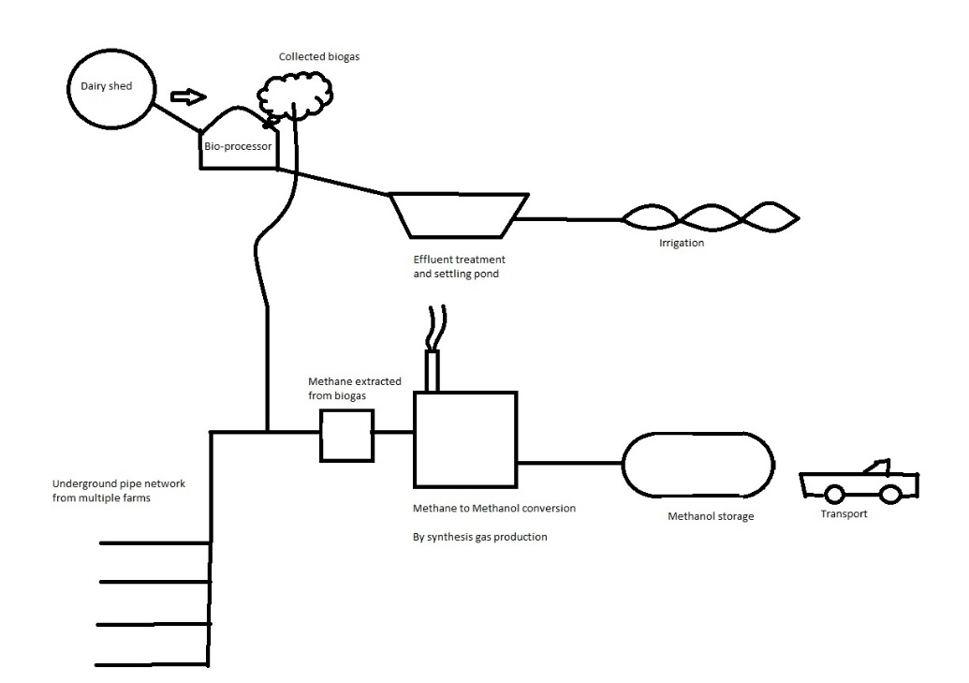
Figure 1: Methanex biogas venture concept

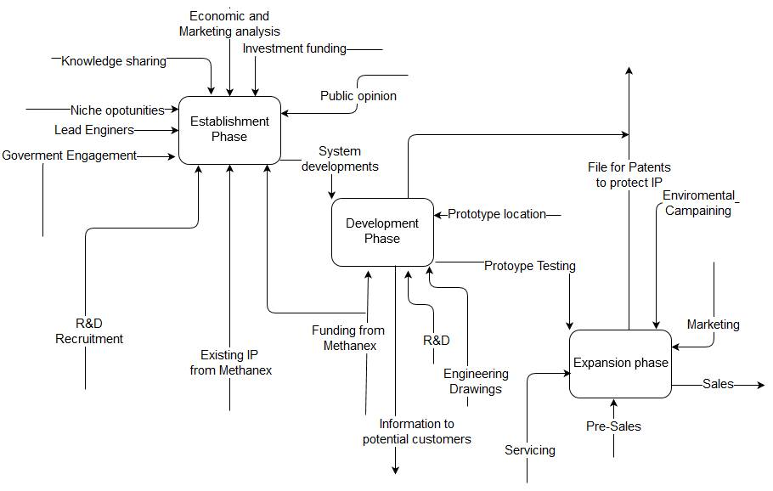
Figure 2: IDEFO diagram of the concept

3.2 The company
Methanex’s highly skilled and diverse workforce in New Zealand includes approximately 250 employees with additional support from local contractors. Methanex is an important contributor to the local and national economy. In 2013, an economic report prepared by Business and Economic Research Limited forecast that Methanex contributes NZD440 million to Taranaki's GDP and NZD650 million to New Zealand’s GDP annually at full production from its existing natural gas fed plants.
Methanex New Zealand’s team members are committed to the principles and ethics of Responsible Care, consistently exceeding the requirements laid out by local and central government. [1]
The New Zealand dairy farming sector is an obvious source of abundant biogas, which is composed of 60% methane and 40% carbon dioxide. It is the intention of this new company venture to exploit the business potential in this abundant source of eco-approved energy.

4. Risk Assessment

4.1 Introduction
A detailed risk assessment was carried out on methanol production through on farm bio-processing. The assessment was undertaken to analyse the risks of the project undertaken by Methanex New Zealand Limited. Opportunities as well as threats to the venture where investigated. The risk assessment was carried out in full accordance to ISO31000:2009 “Risk Management – Principles.”

4.2 Scope
Six key areas where taken into consideration when undertaking the risk assessment. Each area has its own specific objective.
Key Area | Objective
Political | Gain political support on a regional and national level for the project in the form of publicity or money.
Economical | Minimise manufacturing and distribution costs, as well as ensuring the financial wellbeing of the project is safeguarded.
Social | Ensure that in all aspects of the venture the effects on local communities are considered.
Technological | Ensure that the product is durable, of a high standard and does what it was designed to do.
Environmental | Minimise harm to the environment and comply with all the relevant sections of the Resource Management Act (RMA, 1991).
Legal | To comply with all relevant laws in New Zealand and to reduce product liability as much as possible to create a device that can easily insured.

4.3 Analysis
Each risk was analysed and given an assessed risk level and placed on the risk map. The full results of the risk analysis can be found below.

4.4 Risk table

Colour Key | Risk, Threat or Opportunity | Who should be informed? | Action Required
 | High Risk Loss | Directors | Requires senior management to design deliberate treatment action plans and specified responsibility.
 | Medium Risk Loss | Top Management | Attention of senior management needed to develop specific response or monitoring procedure , and the specification of management responsibility
 | Low Risk Loss | Immediate supervisor | Manage with routine procedures, no specific extra resources required
 | Negligible Risk or Gain | Work Team | Business as usual. Manage with routine procedures and general monitoring
 | Low Opportunity | Immediate Supervisor | Manage with routine procedures or specific monitoring
 | Medium Opportunity | Top Management | Attention of senior management needed a management responsibility specified.
 | High Opportunity | Directors | Detailed planning required at a senior level to prepare for and capture opportunity

Figure 3: Risk Register Key

Approx. Frequency (Per Year) | Description | Likelihood | Negative Risk Area (Threat) |  |  |  |  |  | Positive Risk Area (Opportunity)
1 | Annual Occurrence | Almost Certain |  |  |  |  |  |  |  |  |  | 33 |  | 1
1/3 | Has Occurred Several times in a lifetime | Likely |  |  | 30 | 19, 25 | 2 |  |  |  |  | 6, 10, 22, 28 | 4, 18 | 3, 11, 32
1/10 | Occurred once in a lifetime | Possible |  | 31 | 24, 26 | 23, 27 |  |  |  |  |  | 5, 14 | 17 | 7, 13, 34
1/30 | Occurs somewhere from time to time | Unlikely | 8, 15, 37
1/100 | Heard of it happening elsewhere | Rare | 36 | 12, 29 |  | 21
1/1000 | Have never heard of it happening | Very Rare | 16, 28 | 9 | 35
1/10000 | Theoretically possible but not expected to occur | Almost Incredible
 |  | Consequences | Severe Loss | Major Loss | Moderate Loss | Minor Loss | Negligible Loss | Neutral |  | Negligible Gain | Minor Gain | Moderate Gain | Major Gain | Huge Gain

Figure 4: Risk Register Results

5. Project plan

5.1 Introduction
The Project has been broken down into three phases. Each phase has been broken down into a number of key sections.

5.2 Discussion of project plan
1. Establishment phase 07/09/2016 – 09/10/2017
The first of three phases is all about building relationships with the relevant groups in New Zealand as well as continuing improvement of system components with the mind-set of establishing a prototype system.
- Prioritising Goals: Decide what goals the project wants to achieve.
- Economic Analysis: Investigate New Zealand and International applications of biogas methanol production, compare project to existing systems to explain benefits and cost.
- Market Analysis: Investigate the biogas market in New Zealand, focusing on utilising manure from dairy farms. Focus initially on current potential economically viable sites with incentives from local government to pursue this type of project. Keep an up to date directory on market developments.
- Knowledge sharing: Inform and share knowledge to government (local and national) as well as Farmers who could potential benefit from system.
- Funding of Project: Look to secure funding for project, first looking towards government to see if there are any cash incentives that can be utilised, then finance the rest of the project through investors or company capital.
- Regulations: Engage with law makers and regional councils to inform them of the benefits of the proposed system. Find out what laws and regulations the project would have to comply with.
- Government Engagement
    - Energy point of view:
      - Potential for tax breaks for eco-friendly biofuels
      - Fuel security of New Zealand
      - Government pledge for 90% renewable energies by 2025
      - Clean heat codes and regulations
      - Emissions trading Scheme
    - Environmental point of view:
      - Waste management bill
      - Biogas capture mandates
      - Farm waste management codes
      - Local government guidelines
- Build public opinion: Invest in gaining public support for the project from an environmental standpoint
- Research and development: R&D Methods of improving efficiencies and techniques used in the system.
- Niche opportunities: Identify niche opportunities that occur in New Zealand’s unique dairy industry
- Development Phase 09/10/2017 – 03/06/2019
The development phase of the project primarily focusses on establishing a prototype system involving around 10 farms. It also focuses on proving that the system is beneficial for the farmers involved in the business and for New Zealand as a whole.
- Demonstration of system: Showcase the potential system as well as the uses for methanol e.g. motorised transport, electricity generation.
- Developments of tools and guides: Development of techniques and tools to maximise efficiency of system processes.
- Rollout: Set up prototype system operating on a group of 10 farms.
- Trans-regional partnerships: Push for partnerships between regions in using and transporting methanol product.
- Good agricultural practice: Push for environmentally friendly practices like cleaning up streams, look for solutions to the problem of effluent run-off and disposal.
- Market Analysis: Establish potential for mass roll out of biogas recovery systems. If not already achieved in phase 1, find economically viable sites for systems across North Island.
- Research and development programmes: Strive to improve efficiencies of techniques to maximise economic potential.
- Expansion Phase 04/06/2019 – 08/09/2027
The third and final phase of the project is expanding the project across the whole of New Zealand by capitalising on the planned success of the prototype system. A continuation of investment into R&D to minimise maintenance costs for existing systems will also take place.
- R&D Support mechanisms and regulation: Set up network to support existing systems to try and minimise maintenance costs.
- Natural Gas network for biogas: Set up or join a natural gas network spanning across the North Island.
- Substitution of fossil fuels: Push for increased methanol usage across New Zealand.
- Rural sector scale-up: Push for mainstream roll out among New Zealand Dairy farmers.

6. Financial Feasibility

6.1 Introduction
Manure collection has not typically been practised on New Zealand dairy farms. However, if there is the opportunity to collect manure to help comply with increasingly stringent effluent disposal regulations, as well as potentially harvest energy from the methane gas and reduce odours, the company believes significant interest will arise from the dairy community. In addition, there are possibilities to use the high nitrogen contents of the manure to re-spread the collected manure, through existing irrigation equipment, to reduce dependency on externally sourced fertiliser.
The company aims to create a contract with the farmers, who will purchase our equipment, to collect the methane from the biogas and create high value methanol for distribution to local and international companies for use as a base ingredient for many chemicals, bio-fuels, pharmaceuticals and other high-value products. This will be done through a centralised steam reforming plant, taking the biogas production of ten nearby dairy farms and steam reforming the methane into methanol, which is more easily stored and transported as it is a liquid at room temperature and pressure.
The company will pay for the installation of the bio-processors on the farms. The benefits to the farmer include an improved environmental status as a result of reduced methane emissions and reduced effluent run off, as well as a reduction in fertiliser costs. Overall farm efficiencies will be improved through the implementation of these systems.
The first operational plant, other than the prototype system, will be finished in 2019. The financial outlay up until this point will be $4,539,540.76.

6.2 Methanol plant
The methanol plant will be set up to process the biogas produced from ten farms. The expected feedstock from the dairy farm supply is 4.71 T/yr of methane. This is performed in the local New Zealand context with due considerations for environmental sustainability. The plant is designed assuming a 10-year plant life and 2016 hours of operation per annum.
Table 1: Financial Analysis Assumptions
Inflation | 3%
Marketing and administration | 2%
Tax rate | 28%
Initial global methanol price | $391.6755/MT
Total material cost | $2.56 million per plant
Calculated labour cost for set-up | $341,000
Operational cost (maintenance + labour) | 10% of initial outlay

Estimates of future profits were conducted based on three scenarios – optimistic, expected and pessimistic. This was conducted by adjusting the efficiencies of the methanol plant and inflation of the price of methanol in future years. Maintenance costs were calculated to be 5% of initial cost of plant set-up per annum and labour costs for plant operation after set-up were calculated to be 10% of initial labour outlay. A plant overhaul, costing 50% of the original construction and labour costs, was carried out after 10 years to achieve another 10 years of service life. No new plants were commissioned after 10 years of company operation.
Assumptions that apply to each individual case are listed below:
Table 2: Assumptions for optimistic cash flow
Optimistic
Plant efficiency 30% (conversion of methane to methanol)
Peak Methanol Production of 17,053 MT/year
No unexpected outages
Constant methanol price inflation of 2% per annum
Currency inflation of 3% per annum
100 plants in 10 years

Table 3: Assumptions for Expected Cash Flow
Expected
Plant efficiency of 20% (conversion of methane to methanol)
Methanol Production of 11,370 MT/year
1 unexpected outage of 3 month duration
Constant methanol price inflation of 0%
Currency inflation of 3% per annum
60 plants in 10 years

Table 4: Assumptions for Pessimistic Cash Flow
Pessimistic
Plant efficiency of 15% (conversion of methane to methanol)
Methanol Production of 8,526 MT/year
2 unexpected outages of a total duration of 6 months
Constant methanol price inflation of -2% per annum
Currency inflation of 3% per annum
40 plants in 10 years
Figure 5: Company Profit per year

Figure 6: Cumulative Company Profit per year

Figure 7: NPV

6.3 Results Summary
The table below outlines a summary of the statistics of the financials of the company.
Table 5: Overall Financial Statistics
Summary statistics | Payback Period | Net Profit
Optimistic | 12 years | $473 mill
Expected | 17 years | $49.6 mill
Pessimistic | - | -$41 mill (21 years)

6.4 Recommendations
From the above financial analysis it is apparent that the return for the country over 20 years varies depending on the ability to market the product successfully, as outlined in the predictions using optimistic, expected and pessimistic approaches. Seen as dairy farming is the largest section of the New Zealand agricultural sector, it is a recommendation of this report that the financial aspects for the expected outcomes of this venture are secure, considering the investment in marketing and technology that the company is undertaking. However, the net present value analysis displayed in figure 7 highlights that it would be best to invest the money in other ventures as an external investor, unless optimistic projections are met. There are however other benefits that Methanex New Zealand Limited will benefit from as a company operating in the local environment from investment in the biogas to methanol venture.

7. Route to market

7.1 Introduction
A successful marketing strategy is key to ensure a maximisation in profit. Successful marketing will ensure that all opportunities that present themselves can be fully capitalised and at the same time threats that may present themselves can be minimised. Relying on the quality of the product itself to influence sales is an unnecessary high-risk strategy. It is important to focus on strategy rather than the product itself. The marketing department of the project should constantly be up-to-date with emerging opportunities that may present themselves throughout the project. Possible key marketing achievements include the following:
- Support from local communities
- Support from local government
- Support from national government
- Attracting investors
- High sales
Threats that are minimalised by implementing a good marketing strategy are:
- Insufficient funds
- Community/Government backlash to the project
- Resource consent denied by government

7.2 Methodology
1. Selecting Target Market:
Extensive market and economic analysis is to be undertaken to fully understand the dairy industry in New Zealand. This project targets dairy farmers with an average or above average size herd. The potential to save money as well as producing a “Greener” product are the selling points of this project, with emphasis on the “Greener” product aspect. This will mean that the product that the farmers are producing will be held in higher esteem and also appeals to farmers who are more environmentally minded. Because of this Methanex needs to drive hard the benefits of using dairy cow manure to produce fertiliser and methanol. Investors inside New Zealand are to be sought after the most, followed by other companies in the energy industry such as Contact or Meridian energy.
- Product
Producing methanol from methane is a relatively well explored technology, producing methanol on the small scale that is suggested in this project is however new and innovative. R&D engineers will need to be hired to help improve existing larger scale components so that they can be scaled down and applied in an efficient and economically beneficial way.
- Pricing
In this project the farmer does not pay for the system to be set up. In doing so they are agreeing to have the system set up on their farm, getting in return a “greener” dairy product as well as fertiliser for their fields. What Methanex gets out of this agreement is the methane produced by the manure. If this set up is not attractive enough to potential clients, deals can be struck that could see clients getting a return on the profits made my Methanex on their project. An extensive financial feasibility investigation is shown in a separate part of this report. This serves as the best research into pricing trends on methanol and expected turnover and profit of the venture. Market trends will be monitored to ensure a financially viable future for the project.
- Promotion
The promotion is heavily linked with the success of the prototype project. The marketing strategy revolves heavily around the perception that producing methanol from dairy farms is hugely beneficial to the environment. Many high value opportunities identified in the risk assessment are linked to the promotion and the positive image. Dairy farming in New Zealand has many negative environmental connotations associated with it. It is therefore vital that this is used as an advantage when informing people about how producing methanol from methane is an activity which can help the environment and New Zealand’s green image. There are many ways of passing on information about the positives of this process:
- Local community meetings
- Presentations to industry leaders
- Presentations to the educational community (Schools, University’s etc.)
- Sponsoring of eco-friendly initiatives and events
The sub categories of the promotion phase of the marketing strategy can be broken down into the following sub categories:
- Positioning: What is the message that states the benefits of the product?
  - For Methanex the positioning is outlined above. For investors the potential to make a profit selling methanol made from bio fuels is the key benefit. It is also however very important to push forward how environmentally beneficial the project will be, this key fact will be crucial to winning over the general public as well as investors who are on the fence about investing. It is also key to convince farmers that the project will be beneficial to them in terms of money saved and the positive impact it will have on New Zealand
- Selling: Direct or indirectly through others?
  - There are two aspects to selling in the project:
    - Selling the methanol: Methanex already has an established catalogue of customers that it already supplies methanol to. There is an opportunity to sell the methanol made through this project at a premium because of its environmentally friendly manufacturing process. Methanex already has the logistical and sales resources to find additional customers to sell methanol too.
    - Selling to farmers the idea allowing methane to set up biogas systems on their farm: To achieve this Methanex will directly contact possible farmers via the public relations and marketing department which will be solely working on this project. The goal will be to convince the farmers that having free fertiliser and a greener product is worth having a biogas system on their farm.
- Communications: How will people be informed about the product?
    - The major goal of Methanex with this project is to inform the farming community about the benefits of having a biogas system on their farm. The success of the prototype system will be crucial in showcasing this throughout the project. Before and after prototype construction a sustained effort to recruit new farmers and spread information will be carried out in the form of advertising at farming events, information evenings and meetings.
- Support and service: How Does the customer get help if systems aren’t performing?
  - The biogas systems on the farms will be owned and operated by Methanex, any repairs needed to the system are payed and budgeted for by Methanex, who will be taking an active role in the upkeep. Methanex is a well-established company, it has customer service systems in place should a farmer have any problems with the system.
To ensure that the marketing strategy listed above is implemented properly and successful, several things need to be formed within the project:
- DMU (Decision making unit)
A DMU consists of all people within the project who play a role in any decision making on spending finances. The DMU’s goal is to have successful communication between everyone with the unit.
- DMP (Decision making process)
A DMP is the process which everyone in the DMU should follow, this process should be freely available and clear for everyone who reads it to understand.

7.3 Competitive Advantage

7.3.1 Definition
Competitive advantage is defined as an advantage that a company has over its competitors that it can leverage to obtain greater market share and profits, allowing it to be more successful in the market. Competitive advantage can be obtained through a number of methods, each of which have their own strengths and weaknesses.

7.3.2 Relevance
The success of the new Methanex venture depends very much on market uptake. Methanex must aim to create a sustainable competitive advantage with the methanol plants to achieve long term gain.

7.3.3 Resource based competitive advantage
Resource based competitive advantage operates on the principle of creating a rare, inimitable and valuable product. The creation of a service with these attributes will create a desire for market uptake and increase sales over competitors. Sustainable competitive advantage is difficult to achieve due to the high likelihood of change in one of the characteristics outside of the control of Methanex.

Figure 8: Resource based competitive advantage

7.3.4 Recommendation
It is recommended that Methanex focus on distributing the methanol produced from bio-gas through its existing network of methanol customers and even perhaps add a premium for the added benefit that the methane to create the methanol has been sourced renewably. The relatively high manufacturing and operating costs for this new venture of the Methanex Company render a cost leadership structure ineffective. Methanex must differentiate themselves from competitors. The nature of the venture is well suited to this seen as there is no commercial operation collecting biogas for methanol production operating locally or abroad. Methanex has an existing advantage as it already possesses the know-how of methane to methanol conversion via steam reforming. All it must do is successfully implement this process, using dairy farm biogas rather than natural gas feedstock. Therefore, if Methanex can simply commission and operate their methanol plants a competitive advantage will be created immediately.

7.4 Intellectual Property

7.4.1 Background
Intellectual property is usually enforced in the form of patents for technological ventures. They do not give the holder the right to develop a certain technology or invention, but rather exclude other parties from doing so. In this way, patents are an effective means to ensure competitive advantage as they enable the holder to develop a unique product or invention. Patents are usually valid for a period of 20 years, meaning that the advantage gained by the holder of the enforced patent is temporary, allowing others to implement the same technology after patent expiry. A patent can be sold, licensed, mortgaged, assigned, given away or abandoned.

7.4.2 Approach
A key activity during the risk assessment phase that was identified was obtaining protection for intellectual property. It is useful for maximising identified opportunities, such as maximising competitive advantage over rival companies and minimising threats. The process of steam reforming methane into methanol is already an established process that Methanex undertakes on a large scale using natural gas feedstocks. The biogas venture would simply involve extending the existing procedures and know-how of steam reforming that Methanex has for the new biogas context. There are existing patents surrounding these procedures that Methanex already holds or uses under license. However, in terms of bio-processors, the system is relatively simple and there is a good opportunity to improve its efficiency through technological know-how. There is a threat that rival companies may have patents already complete or pending, meaning there may be an associated cost in terms of legal settlement to negotiate usage terms of the patents. This settlement will be in the form of royalties and would be paid to the patent holder in return for the use of the patented technology.
There is opportunity for multiple patents in the field of creating methanol from biogas due to the innovation that is possible. The technology has existed for some time however it has not been applied in this vain before, so there is opportunity to refine and improve the technology for more efficient implementation. This could lead to new patents from innovations that Methanex has created. Should the innovation prove to be un-patentable, Methanex should aim to maintain secrecy regarding their developments.

7.4.3 Current patents
New Zealand
The Intellectual Property Office New Zealand (IPONZ) which stores a database of all current patents in New Zealand contains a lot of patents on processing using methane. Examples of patents issued in the past in New Zealand involving methane and methanol include:
- Method for producing methane from biogas
This patent has expired since being issued.
Worldwide
There is a breadth of information available surrounding global patents involving the process of steam reforming to produce methanol from methane. The process is still being developed to improve efficiency. Listed in the appendices is a list of currently relevant patent literature surrounding the steam reforming process and the production of methanol from methane.

7.4.4 Summary
Methanex New Zealand Limited holds a variety of other patents on proprietary technology it has developed in order to maintain its New Zealand assets. It operates on a daily basis converting methane to methanol from a natural gas feedstock, so this part of the process should not require any new patent developments. The technology surrounding bioprocessing of organic waste to create biogas has existed for a number of years and is open to further development to improve system efficiencies. There are no current patents involving this specific application of the technology currently issued in New Zealand. It is therefore recommended that Methanex develop the specific application of this technology process and look into the possibility of patenting the procedure as it develops and improves the operation of each of its plants in the early stages of this new business venture. Furthermore, the technology will undergo changes and improvements so the opportunity for future patent application is great, providing a method to secure a mid-term competitive advantage.

8. Sustainability
A detailed analysis of the company’s actions was undertaken to determine the sustainability of the venture. Further details are outlined in the appendix.
The three pillars of sustainability were used to analyse the impacts of the venture.

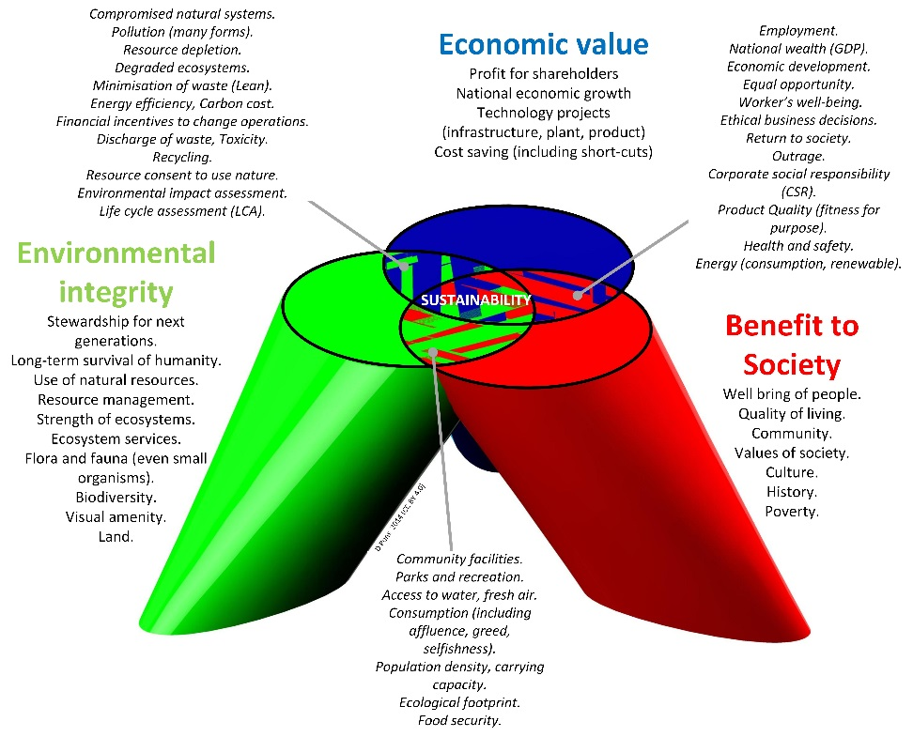
Figure 9: Three Spheres of Sustainability [2]

8.1 Economic Sustainability
Methanol is a very high value product used as a building block for a variety of everyday products and applications and is also used as a clean-burning alternative energy source. The large source of biogas available in New Zealand has the potential to be harnessed to create meaningful energy sources and products. The venture will add economic benefits to local farmers in the form of reduced fertiliser costs and potential access to government financial incentives to reduce greenhouse gas emissions. In addition, it will add value to the national economy through job creation in construction and management of the methanol plants and the production of high value methanol products.

8.2 Social Sustainability
The venture in methanol production from biogas has the potential to add great social value to the local community. The added economic value outlined above has an inherent flow on effect for social sustainability, as it has an impact at the local level. As jobs are brought to the local community and more labour is required, the social well-being of the immediate community will benefit as the economic sustainability of the regions increase.

8.3 Environmental Sustainability
There are a number of environmental benefits associated with the venture. Principally, the reduction in methane emissions is beneficial to all parties. Methane is over 20 times more harmful than carbon dioxide as a greenhouse gas. Another benefit is the reduction in effluent run-off and the reduced necessity for powerful nitrogen fertiliser usage leading to algal blooms that are responsible for severe pollution of New Zealand waterways. The reduction of odours is also another benefit for farm neighbours and communities. Methanol can be used as a sustainable fuel or as a component of environmentally friendly biofuel. By lowering society’s dependence on traditional fossil fuels it is hoped that alternative fuel availability, such as methanol or its derivatives, will encourage the necessary shift in thinking to lead to true environmental sustainability.

9. Human Resources
The table below outlines the standard rate and the total amount of hours contributed to the project by each employee. Further details regarding human resources can be found in the appendix of the report.
Resource Name | Std. Rate | Total Hours | Cost Throughout project
Secretary | $40.00/hr | 473.95 | $18,958.05
Lead Project Engineer | $120.00/hr | 7,389.95 | $886,794.15
Administration assistant | $40.00/hr | 560.00 | $22,400.00
Project Engineer | $80.00/hr | 8,009.83 | $640,787.20
Methanex General Employee | $120.00/hr | 112.00 | $13,440.00
Economic Analysis | $65.00/hr | 3,624.00 | $235,560.00
Economic Analysis 2 | $65.00/hr | 3,680.00 | $239,200.00
Human resource manager | $60.00/hr | 519.81 | $16,308.86
Methanol specialist | $120.00/hr | 504.55 | $60,545.59
PR Manager | $70.00/hr | 14,424.27 | $1,009,138.99
PR Manager 2 | $70.00/hr | 17,264.00 | $1,207,920.00
Lawyer | $200.00/hr | 1,439.45 | $287,888.00
Marketing Manager | $60.00/hr | 13,404.00 | $803,760.00
Marketing Manager 2 | $60.00/hr | 17,264.00 | $1,035,360.00
Contractors | $80.00/hr | 168.00 | $13,440.00
Civil Engineering team | $500.00/hr | 776.00 | $388,000.00
Head Civil Engineer | $150.00/hr | 608.00 | $91,200.00
Chemical Engineering team | $500.00/hr | 7,352.00 | $3,676,000.00
Head Chemical Engineer | $150.00/hr | 6,064.00 | $909,600.00
Mechanical Engineering team | $500.00/hr | 168.00 | $84,000.00
Head Mechanical Engineer | $150.00/hr | 224.00 | $33,600.00
Workshop technician | $100.00/hr | 728.00 | $72,800.00
R&D Engineer | $120.00/hr | 8,448.00 | $1,013,760.00
 | Total |  | $12,760,460.84

10. Communication Plan

Identify stakeholders and grants
New Zealand based organisations with expertise in biogas and methanol production actively engaged in these industries are listed below.
Suppliers
AECOM | Consulting engineers: civil, energy, environmental planning and industrial design
University of Canterbury | Research and consulting
Bioform | Consulting: agro-business
BECA | Consulting Engineers: civil, wastewater, mechanical, environmental planning and industrial design
Eastharbour | Consulting Engineers: energy planning
Greenlane/Flotech | Equipment Suppliers: biogas upgraders, compressors
NIWA | Research and consulting: small scale biogas systems for wastewater and farm waste treatment, advanced biogas utilisation, improved AD nutrient reuse
PGG Wrightson | Advisors and Suppliers: agro business
Ravensdown | Fertiliser suppliers and agro advisory
Methanex | New Zealand’s only methanol production unit
Operators
Christchurch City Council | Operators of landfills, wastewater treatment plants, co-digestion, solids drying, and biogas transfer network. New Zealand’s first biogas tri-generation plant
Dunedin City Council | Operators of digesters and landfills
Fonterra | New Zealand’s largest dairy cooperative  Operators: wastewater digester and boilers
Hamilton City Council | Operators of digesters
Palmerston City Council | Operators of digesters and co-digesters
Transpacific Industries (NZ) | Operators of landfills  Also hosting a pilot project – NZ’s first biogas powered rubbish truck
Watercare Limited | Operators of digesters
Wellington City Council | Operators of landfills and sludge treatment plants
Landcorp Rangiora | Biogas CHP system based on dairy cow manure digestion in heated mixed digesters
Gas
Contact energy | Gas suppliers and distributers
Genesis energy | Gas suppliers and distributers
Greymouth petroleum | Gas suppliers and distributers
Mercury energy | Gas suppliers and distributers
OnGas | Gas suppliers and distributers
[3]

Appendices

1. Introduction

1.1 General
The raw material used to produce biogas is called ‘feedstock’. The feedstock (e.g. manure) is collected and held in tanks or ponds, the gas produced is captured, and this is used either as fuel in its own right (to heat buildings or power vehicles), or to drive a generator that provides electricity. Systems for extracting and using biogas on farms have been used for decades in Europe and North America. A biogas system may be as simple as fitting a cover to ponds, or as sophisticated as a fully automated off the-shelf system using tanks. A well-designed system offers other benefits: odour control, reduced contamination of groundwater and production of bio fertiliser.
Manure from the farm’s 900 cows is collected on a concrete pad outside the milking sheds, and pumped into a tank digester. The gas produced is used to power a generator that provides around a third of the farm’s energy requirements. There are environmental benefits to the biogas system also. The digestate that comes out of the tank is very low in pathogens compared to raw manure, and is ready for use on paddocks as an effective bio fertiliser. This comes on top of the reduction in carbon emissions from using up methane in the biogas.

1.2 Environmental
Methane has 20 times more greenhouse gas effect than carbon dioxide. The process of burning biogas for electricity generation and/or heat or to power an internal combustion engine converts methane into carbon dioxide, so this significantly reduces total greenhouse gas emissions.
By extracting methane out of waste and using it to produce heat and/or electricity the company can ensure that the waste will not degrade in an open environment therefore reducing direct methane atmospheric emissions. Moreover, the energy provided by the biogas is likely to displace fossil fuel which is the main contributor to greenhouse gas emissions.
Biogas energy is considered carbon neutral, since carbon emitted by its combustion comes from carbon fixed by plants (natural carbon cycle).
Despite popular belief, the amount of waste going in the digester is almost equal to the amount coming out. However the quality of the waste is altered for the better (less odour, better fertilizer, organic load reduced, less polluting).
Waste coming out of the digester can be separated (solid/liquid): the solid part can be composted and the liquid part can be used as liquid fertilizer or can be treated further and disposed.

2. System Architecture

2.1 Process of steam reformation of methane into methanol [4]

2.2 Process Flow Diagram – methane to methanol
Figure 11: Process flow diagram of steam reformation of methane into methanol
[4]

3. Risk Assessment

3.1 Risk register

Reference | Risk | Recommended action / Treatment | Consequence | Likelihood | Consequence
Political
1 | Implementing methane gas systems would be a good thing for the environment which would appeal to many New Zealanders | 1. Pass on information to general public of the benefits of these systems to the environment by running informative advertising across many forms of media  2. Appeal to Green minded political parties and MPs to inform their electorate of the benefits to the environment | Huge gain | Almost certain | High Opportunity
2 | Potentially lead to shutdown of Huntly PowerStation which would lead to loss in jobs and money for local region, this will displease the people of Huntley | 1.Stress that replacement jobs will be created by the project  2. Base operations In Huntly. | Negligible Loss | Likely | Low Risk Loss
3 | Able to apply for government funding, which would help project finances significantly | 1. Organise a convincing campaign to get government funding  2.Apply for largest sum of money | Huge Gain | Likely | High Opportunity
Economical
4 | Save dairy farmers money on fertiliser bills | 1.Ensure that fertiliser demand of farmers is met by system | Major Gain | Likely | High Opportunity
5 | Create Jobs in manufacturing and servicing industries | 1.Strive to manufacture components within New Zealand  2.Work with existing New Zealand farm service providers | Moderate gain | Possible | Medium Opportunity
6 | Makes New Zealand product more desirable internationally | 1.Reasearch how green image effects overseas sales  2.Make these benefits known to potential customers | Moderate gain | Likely | Medium Opportunity
7 | Opportunity for export of New Zealand methane technology | 1.Search for similar gap in market outside of New Zealand  2.Inform possible international clients of benefits and New Zealand testing | Huge Gain | Possible | High Opportunity
8 | Run out of funding before product is able to be mass marketed | 1.Manage funds and plan expenditure  2.Have back up funds available 3.Constantly look for investors | Severe Loss | Unlikely | High Risk Loss
9 | Country enters economic hardship before product is mass marketed | 1. Secure funds as soon as possible after they are promised  2.Look at investors from over seas | Major Loss | Rare | High Risk Loss
10 | Obtain funding from overseas governments who are also interested in implementing the technology | 1.Search for countries with similar industries 2.Inform them of the benefits | Moderate gain | likely | Medium Opportunity
11 | Make a lot of money if technology is successfully applied on a large scale | 1. Ensure that once benefits have been quantified that this information is widely available  2.Ensure that ability to manufacture is able to keep up with demand | Huge gain | likely | High Opportunity
12 | Lack of funding to hire competent people | 1.Secure funding early and set aside a sufficient amount to hire people with enough expertise | Major Loss | Rare | High Risk Loss
13 | Free advertising opportunity's from interested media | 1.Send information packs to all forms of local and international media when a major target has been reached | Huge Gain | Possible | High Opportunity
14 | Required technology already exists , so R&D costs are about making technology more viable on a smaller scale | 1.Reasearch existing patents in related areas | Moderate gain | Possible | Medium Opportunity
15 | Market competitor releases another product with similar benefits | 1.Ensure that security procedures are in place to prevent espionage  2.Reasearch market to make sure that competitors are not able to do so | Severe Loss | Unlikely | High Risk Loss
Social
16 | Severe Injury or death due to misuse of technology | 1.Ensure that systems comply with relevant standards  2.Ensure that customers are trained and well informed on how to safely operate systems | Severe Loss | Very Rare | High Risk Loss
17 | New Zealand population get on board with the idea | 1.Capitlise on interest of public and hold meetings and spread information | Major gain | Possible | Medium Opportunity
18 | Project showcases New Zealand as a positive example to the rest of the world, which could lead to more business | 1.Have projections on benefits for other countries with possible markets ready for when possible overseas customers are interested | Major gain | Likely | High Opportunity
19 | Project causes job reduction for small towns near Huntly PowerStation | 1 Where possible manufacture components in towns effected by closer of power stations | Minor loss | likely | Medium Risk Loss
20 | Project creates manufacturing and servicing jobs | 1.Ensure manufacturing jobs stay in New Zealand | Moderate gain | Almost certain | Medium Opportunity
21 | Vandalism of instruments from members of public whose jobs are negatively effected | 1.Ensure that test system has high level of security 2.Work with local communities to address grievances | Minor loss | Rare | Low Risk Loss
22 | Cements New Zealand's image of being an innovative nation | 1. Inform government of likely benefits 2.Captilise on any advertising government offer | Moderate gain | Likely | Medium Opportunity
23 | Ascetics of systems could be viewed negatively | 1.Consult an audience of people who live near where systems will be put into place | Minor loss | possible | Medium Risk Loss
Technological
24 | Early system gets damaged or misused | 1.Have spare parts manufactured 2.Educate operators of early devise on how to operate properly | Moderate loss | possible | High Risk Loss
25 | System could require high levels of Maintenance | 1. Design systems with ease of maintenance in mind | Minor loss | likely | Medium Risk Loss
26 | Problems manufacturing large numbers in New Zealand | 1. Plan for large manufacturing order 2.Have back up manufacturing facilities | Moderate loss | Possible | High Risk Loss
27 | Failing of components in prototype system | 1.Test each component before testing the whole system  2.Have spare parts ready to replace broken ones | Minor loss | Possible | Medium Risk Loss
28 | May find possible improvements to the system during prototype system testing | 1.Test porotype system and be open to changes in design | Moderate gain | Likely | Medium Opportunity
29 | Some possible locations may be highly inaccessible | 1.Design components with ease of transport in mind 2.Design components so that they can be transferred up gravel roads | Moderate loss | Rare | Medium Risk Loss
30 | Difficulty in extracting all of methane from manure | 1.Set aside a larger proportion of R&D budget to solve the issue | Major loss | likely | High Risk Loss
31 | Unable to collect manure efficiently | 1.Set aside a larger proportion of R&D budget to solve the issue | Major loss | possible | High Risk Loss
Environmental
32 | Reduce reliance on fossil fuel generated power in the North Island | 1.Keep possible clients informed on what is being achieved | Huge gain | likely | High Opportunity
33 | Reduce harmful effects of methane from cow manure | 1.Reasearch the benefits of burning methane rather than releasing it into atmosphere | Moderate gain | Almost Certain | Medium Opportunity
34 | Improve New Zealand’s Waterways by reducing amount of manure | 1. Inform clients about harmful effects of manure in waterways and benefits of using it to burn instead | Huge gain | Possible | High Opportunity
35 | Carbon footprint of manufacturing instruments outweighs benefits | 1. Try to produce components in south Auckland/Waikato to reduce transportation footprint. 2.Try to use materials available as locally as possible | Moderate loss | Very Rare | Medium Risk Loss
Legal
36 | Patent may have already been submitted that will restrict use of certain components | 1.Research patients before committing major time and money | Severe Loss | Rare | High Risk Loss
37 | Planning consent denied for systems | 1.Researrch planning rules and put time and m9oney aside to make sure that submissions are of a high standard | Severe Loss | Unlikely | High Risk Loss
38 | Industrial espionage from employees could set back project | 1.Invest in security of physical and virtual IP | Severe loss | Very Rare | High Risk Loss

3.2 Liability risks
Figure 12: Liability fault tree analysis

3.3 Functional Failure risks
Figure 13: Functional Failure Fault Tree Analysis

3.4 Health and safety risks
Figure 14: Health and Safety Fault Tree Analysis

4. Financial analysis

4.1 Cash flow analyses
Cash flow analyses were conducted for each of the scenarios for optimistic, expected and pessimistic future predictions.

Figure 15: Cash flow for Optimistic Prediction

Figure 16: Cash flow for Expected Case

Figure 17: Cash flow for Pessimistic Case

4.2 Equipment costs
Table 6: Equipment cost for Bio processor
Item | Cost
Total pipe cost (10km) | $8,505
Installation cost | $8,505
Bio-processor equipment | $96,000
Foundation | $12,040
Digester | $22,152
Roof | $7,223
Gas pump | $3,371
Boiler | $2,889
Hydra-ram manure pump | $23,600
Supplies | $15,900
100 m^3 methanol storage tanks | $5,000
Methanol Plant set-up | $50,000

4.3 Potential cost reductions to the farmer
Table 7: Cost of fertiliser [2]
Item | Cost
Fertiliser cost saved (Urea) | $5,275 per annum

4.4 Unconsidered costs
Other costs that have not been considered within the cash flow analysis of the company include the cost of land that the plants are situated on. Land hire costs have also not been considered for the case when farmers refuse to provide space for bio-processors on their own land for free. If the venture is still deemed to be unattractive to the farmer then a small percentage of the annual revenue of the plant will have to be attributed to paying the farmer for the use of their land.

5. Route to market

5.1 Patent literature
1. Oxidation of methane to methanol
US 4982023 A
ABSTRACT
A marked improvement in yield, in selectivity or in both is obtained in the synthesis of methanol by the homogeneous direct partial oxidation of natural gas or other source of methane when the reactor space is filled with inert, refractory inorganic particles.
Status: Lapsed
Assignee: Mobil Oil Corporation
2. Direct conversion of natural gas to methanol by controlled oxidation
US 4618732 A
ABSTRACT
A process of directly converting natural gas to methanol employs controlled oxidation. The reaction takes place in an inert reactor, i.e. one having internal surfaces which do not affect the reaction, in the absence of a catalyst. The natural gas is intimately mixed with air or oxygen prior to introduction of the mixed gases into the reactor. Reaction takes place at an elevated temperature of 300° to 500° C. and at an elevated pressure of 10 to 100 atmospheres. The percentage of oxygen in the mixture of reactant gases is kept below 20% by volume and is preferably 2 to 10% by volume. Apparatus for carrying out the method is also provided.
Status: Lapsed
Assignee: Gesser Hyman D, Hunter Norman R,Lawrence Morton
3. Method and system for methanol production
US 7910787 B2
ABSTRACT
An apparatus and method of producing methanol includes reacting a heated hydrocarbon-containing gas and an oxygen-containing gas in a reactor; to provide a product stream comprising methanol; and transferring heat from the product stream to the hydrocarbon-containing gas to heat the hydrocarbon containing gas. After removing methanol and CO₂ from the product stream, unprocessed hydrocarbons are mixed with the hydrocarbon containing gas for reprocessing through the reactor. Reactor byproducts are injected into the ground to increase the output of a hydrocarbon producing well.
Status: Active
Assignee: Gas Technologies Llc
4. Method and apparatus for producing methanol
US 8293186 B2
ABSTRACT
An apparatus and method of producing methanol includes reacting a heated hydrocarbon-containing gas and an oxygen-containing gas in a reactor; to provide a product stream comprising methanol; and transferring heat from the product stream to the hydrocarbon-containing gas to heat the hydrocarbon containing gas. After removing methanol and CO₂ from the product stream, unprocessed hydrocarbons are mixed with the hydrocarbon containing gas for reprocessing through the reactor.
Status: Active
Assignee: Gas Technologies Llc
5. Hybrid system for Gasification of Biomass and conversion to synthesis gas suitable for fuel synthesis, with 3 potential applications
US 20070100003 A1
ABSTRACT
Technical challenges of biomass-to-fuels conversion prompted the development of this hybrid system for biomass gasification. In this device, the matter is first pyrolyzed and the resulting vapors are drawn off and run through the char and tar in the second stage with the process steam in a supercritical steam gasification. The resulting gases are then purified by use of an amine wash scrubber. An adiabatic pre-reformer is then employed to break down aromatic compounds that most likely exist in the gas even after steam gasification. This gas is then fed to the main steam reformer, and afterwards the gas is cooled to suitable reaction temperatures for fuel synthesis. With a ratio H/C of 2.0, the gas is suitable for Fischer-Tropsch fuel synthesis, methanol synthesis, or production of hydrogen and carbon dioxide by a water-gas shift.
Status: Active
Assignee: Holley James L, Harris Aubrey L

The following patented technology has the potential to alter and improve the process of producing methanol from methane and could be worthwhile for Methanex to investigate and potentially invest in a license to use the technology.
6. Anhydrous conversion of methane and other light alkanes into methanol and other derivatives, using radical pathways and chain reactions with minimal waste products
WO 2004041399 A2
ABSTRACT
Reagents and methods with low thermodynamic barriers can convert lower alkanes such as methane into methanol or other derivatives. One system uses a small quantity of a non-salt radical initiator such as Marshall's acid, a di-acid peroxide that can be split into two radicals. These radicals will remove hydrogens from methane, to generate methyl radicals. Sulfur trioxide is added, and methyl radicals combine with it to form methylsulfonate radicals. Methane is added, and the methylsulfonate radicals will remove hydrogens from it, to form stable methanesulfonic acid (MSA) while creating new methyl radicals to sustain the chain reaction. MSA that is removed can be sold or used, or it can be split into methanol (which can be used on site, or shipped as a liquid) and sulfur dioxide (which can be oxidized to sulfur trioxide and returned to the reactor). This anhydrous system creates no salts and minimal waste. An alternate system uses a bi-functional reagent with electrophilic and nucleophilic domains (such as a bromate-sulfate compound) to create coordinated proton and electron shifts in methane, using symphoric and anchimeric effects to create transitional intermediates with low energy barriers, allowing selective formation of intermediates that can be cracked to release methanol. Either system can improve the selectivity and yield of methanol from methane.
Status: Active
Assignee: Alan K. Richards
7. Tube Monitor and Process Measurement and Control in or for a Reformer
US 20140105243 A1
ABSTRACT
The invention relates to methods and apparatus of measuring real time temperature conditions within a reformer. The data is then used for process control optimisation, overheat protection, and improved creep damage and fatigue life prediction.
Status: Active
Assignee: Peter Campbell Tait
Owner name: METHANEX NEW ZEALAND LIMITED, NEW ZEALAND

5.2 Notes for inventors and information for patent licensing in New Zealand

Figure 18: IP Protection routes [3]

Figure 19: IP Protection routes [3]

6. Sustainability
Environmental Sustainability

6.1 Biogas motivation drivers

Farm Wastes
Media coverage of pollution associated with animal waste on farms is increasing but rarely positive. Anaerobic digestion is a tool enabling better farm waste management on dairy farms. It offers a significant advantage in being able to minimise odours, make nutrients (nitrogen) contained in farm wastes more plant available, and allow for better timing of effluent land application. Biogas recovery from farm wastes remains one of the very few practical and economical ways of reducing agricultural greenhouse emissions.

Balance of trade
Petroleum is New Zealand’s single biggest import category and is likely to increase in future years. Petroleum imports use up almost all export earnings made by the dairy sector. Every small step that helps to reduce our dependence on imported petroleum is therefore very valuable for addressing our biggest economic problem – the current account deficit. Biogas transport fuel is the most efficient and effective transport biofuel available today and could help to substitute a meaningful amount of our petroleum imports and current account deficit. The use of methanol as a biofuel is outside the scope of this report, however there is a large amount of research and testing being conducted in this field for the use of methanol as a low emission alternative fuel source in cars, buses, aircraft and shipping.

Air Quality
Biogas and methanol have the potential to be used in a number of situations to reduce emissions to air and improve local air quality. An example is the use of Dimethyl Ether, a methanol derivative that is being used in public buses as a clean-burning substitute for diesel fuel, or methanol as a marine fuel to help meet the shipping industry’s increasingly stringent emission regulations and improve global air and water quality.

Nutrient recycling and better waste management
World phosphorus supplies are becoming increasingly scarce and less available, while the production of nitrogen fertilizers is an energy intensive process. Returning both P and N contained in digested originating from wastes that alternatively would have ended up in a landfill or waterway to agricultural land can therefore help to enhance our national phosphorus supply security, and preserve finite natural resources.
[5]

7. Human Resources

7.1 Company structure
Figure 20: Human Resources Hierarchy

7.2 Job Categories and skill sets

Lead Project Engineer
A lead project engineer’s role is to act as the head of the engineering team working on the project. The lead project engineer takes on a general managing role and works closely with leaders from other departments

Project Engineer
General engineering role acts as a bridge between different engineering roles, works on jobs which Lead project engineer is either too busy to do or over qualified

Human Resource Manager
Responsible for all job recruitment, must work well with other team leaders and attract staff with the relevant high level of skills

Methanol Specialist
Takes on a technical advisory role throughout the project and helps sell the project to would be investors and clients.

Lawyer
Responsible for all contractual and legal matters, works with the lead project engineer to ensure that the project obeys all relevant laws. Also helps submit plans for government grants if the project qualifies for them.

Mechanical Engineer
Responsible for installing and checking components of system, Responsible for maintaining scheduling

Electrical Engineers
Responsible for installing electrical components in the system. Will implement and develop user systems and interfaces

Chemical Process Engineers
Responsible for ensuring that all the system components are connected properly and the system as a whole preforms the job it’s intended to do.

Civil Engineers
Responsible for planning and overseeing the building of the plant as well as designing any infrastructure that needs to be put in place (foundations etc.)

Marketing Manager
Responsible for designing and implementing a marketing strategy, will work closers with PR manager and economic analysis.

Secretary
During periods of high work volume it will be the secretary’s job to assist the Lead project engineer, HR and PR manger with administration work.

Methanol Company Employee
General Project worker, duties include helping PR and HR managers with work.

Economic Analysis
Responsible for keeping up to date with market affairs and providing economical information to project leaders so they can make informed business decisions

Public Relations Manager
Responsible for any interaction with people from outside the company, whose main goal is to ensure good public, investor and government opinion about the project and company.

Contractors
Responsible for putting together the infrastructure of each system such as laying pipes or foundations.

Research and Design Engineer
Works in R&D department of the project, primary role is to improve components or processes to make them more efficient or cost effective

Workshop Technician
Builds and designs specific components and tools required for prototype before they can be mass produced

7.3 Full-time equivalent employee breakdown
Highlighted in Blue are the employees that have worked enough hours to be classed as full time workers. Full time workers are classed as people that work at least 40 hour weeks 48 weeks of the year (1920hrs). Highlighted in yellow are workers that have not reached that limit. Just because this limit has been reached it doesn’t mean that they cannot be hired full time. Employees that are close to the 1920hr freehold (PR Manager, 2019) could be considered for full time hire as it would allow them to focus solely on this project throughout the year and allow for lee way should certain tasks take longer than originally thought.

Table 8: Full time equivalent breakdown
 | Hours Worked
Resource Name | 2016 | 2017 | 2018 | 2019 | 2020 | 2021 | 2022 | 2023 | 2024 | 2025 | 2026 | 2027
Secretary |  | 473.95
Lead Project Engineer | 436.80 | 873.15 | 240.00 | 1,208.00 | 2,096.00 | 2,088.00 | 448.00
Administration assistant | 504.00 | 56.00
Project Engineer | 448.00 | 963.60 | 745.03 | 1,221.20 | 2,096.00 | 2,088.00 | 448.00
Methanex General employee team | 112.00
Economical Analysis | 328.00 | 1,168.00 | 2,088.00 | 40.00
Economical Analysis 2 | 328.00 | 1,224.00 | 2,088.00 | 40.00
Human resource Manager | 332.48 | 187.33
Methanol specialist |  | 504.55
PR Manager | 464.00 | 652.27 | 352.00 | 1,528.00 | 2,096.00 | 2,088.00 | 2,088.00 | 1,304.00 | 1,048.00 | 1,044.00 | 1,044.00 | 716.00
PR Manager 2 |  |  |  | 1,208.00 | 2,096.00 | 2,088.00 | 2,088.00 | 2,080.00 | 2,096.00 | 2,088.00 | 2,088.00 | 1,432.00
Lawyer | 242.88 | 844.57 | 352.00
Marketing Manager |  | 208.00 | 240.00 | 1,528.00 | 2,096.00 | 2,088.00 | 2,088.00 | 1,304.00 | 1,048.00 | 1,044.00 | 1,044.00 | 716.00
Marketing Manager 2 |  |  |  | 1,208.00 | 2,096.00 | 2,088.00 | 2,088.00 | 2,080.00 | 2,096.00 | 2,088.00 | 2,088.00 | 1,432.00
Contractors |  |  | 168.00
Civil Engineering team | 224.00 | 384.00 | 168.00
Head Civil Engineer |  | 384.00 | 224.00
Chemical Engineering team |  |  | 952.00 | 1,768.00 | 2,096.00 | 2,088.00 | 448.00
Head Chemical Engineer |  |  | 224.00 | 1,208.00 | 2,096.00 | 2,088.00 | 448.00
Mechanical Engineering team |  |  | 168.00
Head Mechanical Engineer |  |  | 224.00
Workshop technician |  | 480.00 | 248.00
R&D Engineer |  | 480.00 | 2088.00 | 1248.00 | 2096.00 | 2088.00 | 448.00

Bibliography

[1] | M. N. Z. Limited, “Methanex New Zealand Overview,” 6th October 2016. [Online]. Available: https://www.methanex.com/location/new-zealand.
[2] | D. Pons, “Three Pillars Model of Sustainability,” [Online]. Available: https://commons.wikimedia.org/wiki/File:Three_Pillars_model_of_Sustainability.jpg.
[3] | BANZ, “Biogas Strategy,” 6th October 2016. [Online]. Available: http://www.biogas.org.nz/documents/biogas/BANZ-Biogas-Strategy-110224.pdf.
[4] | C. W. N. &. F. You, “Steam Reformation of methane into methanol,” National University of Singapore, Singapore, 2016.
[5] | B. B. Strategy, “Biogas Strategy for BANZ company,” 4th October 2016. [Online]. Available: http://www.biogas.org.nz/documents/biogas/BANZ-Biogas-Strategy-110224.pdf .

